-------+++****\*\*4

**National Fire Safety Month**

Four Steps to Fire Safety in case of fire and the best way to escape. If you hear a smoke alarm in your home...

1) Get out quickly and stay out.

2) If there’s smoke, stay low to the ground when you exit.

3) Meet your family members at a preplanned safe spot.

4) Call 911 or the emergency number from a neighbor’s place.

**News from the Principals Corner**

Did you know the City of Boston runs two magnificent golf courses? The First Tee junior golf program offers participants an introduction to the game of golf from PGA professionals at the [William J. Devine Golf Course](http://cityofboston.us11.list-manage1.com/track/click?u=fbcc39822ccf036066f07f961&id=656b7331b2&e=83e4741c54) in Franklin Park. The program is designed for boys and girls ages 7 to 17 and is **free to Boston residents.**  
  
Registration will open the week of May 30th. Please contact Joe McCabe at [jmccabe@mgalinks.org](mailto:jmccabe@mgalinks.org) or [774-430-9109](tel:%28774%29%20430-9109) with questions.  
  
*Program dates: July 11 - August 22 (Mon. - Thur.)  
Ages 7 to 11: 8:30 a.m. - 10:30 a.m  
Ages 12 to 17: 11 a.m. - 1 p.m.*

**Franklin Roosevelt School**

**Big Time News June 1, 2016**

****

**Big Time News**

**May 4, 2016**

School Open Bunker Hill Day

Friday, June 17

**Save the Date**

**Spring Art Show @ Lower Campus**

**June 16 @ Lower Campus**

**5:30 – 6:30 pm**

Come see your child for a fun night! Each class will sing a song and their art will be on display throughout the building. We ask for the students to arrive 10 minutes early to prepare!



***Read To Ride***

Dependable Cleaners is raffling off one bike every week from May 16-August 12.

Children between the ages of 6 and 15 can participate in Read to Ride by reading books and filling out entry forms for each book they read.  Completed entry forms can be dropped off at any Dependable Cleaners location.  The closest locations are in Milton and Dorchester. Entry forms can be picked up at any [Dependable Cleaners](http://www.dependablecleaners.com/locations) and they were also sent home with your child.  You can also download it at: [www.dependablecleaners.com/read-ride](http://www.dependablecleaners.com/read-ride). The more books your child reads the more chances they have to win!  Each entry form will be entered into a drawing to win a brand new bike. Drawings will take place every Monday beginning May 16th until Aug 12th, 2016.

**K -1 update**

The K1 team has moved into our Things that Grow unit! We are excited to watch our caterpillars and ladybug larvae grow and see the whole life cycle! In connection to our unit, we are also growing grass and beans in the classroom. We also planted in the new outdoor classroom. The K1 classrooms will be taking a trip to NRT (Natural Resource Trust) in Easton, MA next week to explore bugs and nature. This unit is filled with lots of hands on learning opportunity.

**SPC CORNER:**

**SAVE THE DATE for FIELD DAY 2016:**

Lower Campus Friday June 10th

Upper Campus Thursday June 16th

We will be looking for **parent volunteers** at both campuses.  We need your help to make this a success!!!  There will be sign ups available thru Facebook page by the beginning of next week and sign-up sheets will also go home next week.  More details to come!!!!

Any questions or concerns please contact one of the co-chairs: Pam Bellamy [blish3939@hotmail.com](mailto:blish3939@hotmail.com) or Jayme Washington at  [jayme@wpaboston.com](mailto:jayme@wpaboston.com" \t "_blank)

https://ssl.gstatic.com/ui/v1/icons/mail/images/cleardot.gif

**ESL Students**

- 2016 ACCESS scores have been released! ESL teachers will meet with teams to determine new English Language Development (ELD) levels for SY2016-2017. Be on the lookout for ACCESS score reports and placement letters, which will go home to parents within the next two weeks. Please call or email your child's ESL teacher if you would like to schedule a meeting to review your child's scores.

- The BPS Summer Enrichment Program for ESL students in grades 2-8 is now accepting applications!  This enrichment program offers students’ academic support as well as enrichment experiences and field trips.  Please return your child's application ASAP.

**Before and After School Program at Lower Campus**

The Roosevelt School is excited to begin registration for our before and after school program for the 2016-17 school year at Lower Campus. We are pleased to announce for next year, we will service grades k1-grade 2.

For more information, please email Ms. Antonelli at [lantonelli@bostonpublicschools.org](mailto:lantonelli@bostonpublicschools.org) or 617-635-9280.

Upper Campus will continue to have before school, as a drop in service!

.

**Tech Corner**

**Dance Mat Typing**

<http://www.bbc.co.uk/schools/typing/flash>

Work your way through 12 stages to learn how to type!  This is a fun and engaging way to learn keyboarding skills.

C\*

# 

**Notes from the Nurse**

Please come to school to pick up your son’s/daughters unused medication at the end of the school year. Medication left at school will be disposed of after June 24, 2016. We are not allowed to send medication home with students due to school policy and state law.

Have a safe, fun and healthy summer!

Nurse Louis Letang, Lower Campus Nurse Myers, Upper Campus

Memorial Day

Memorial Day honored by 3rd graders. On Friday 3rd grade students found out to our beautiful green roof to plant Flags in honor of

**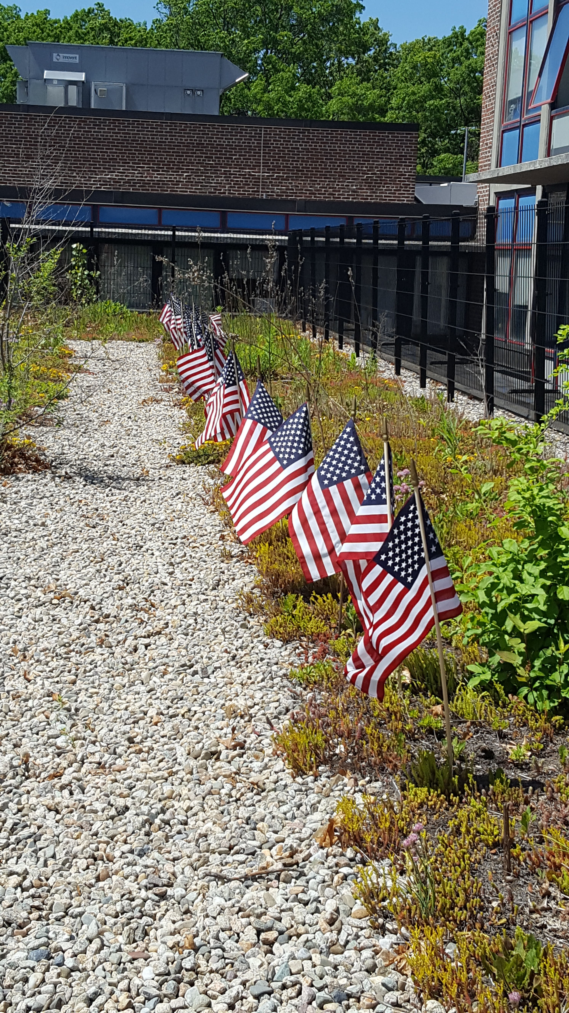**d by 3rd graders. On Friday 3rd grade students found out to our beautiful green roof to plant Flags in honor of Memorial Day.

rial Day honored by 3rd graders. On Friday 3rd grade students found out to our beautiful green roof to plant Flags in honor of Memorial Day.

**B.A.D.D.**

**Boys and Dedicated Dads**

On Friday, June 3 the third grade boys and their dads will celebrate the successful start of the B.A.D.D initiative.  Thanks to all the students, staff and supporters for their words of encouragement, contributions, and help as we move forward and plan for another year.

**Franklin D. Roosevelt School**

**Principal Lynda-Lee Sheridan**

**Assistant Principal Bannet Steele**

**Upper Campus**: 95 Needham Road, Hyde Park, MA 02136

P: 617-635-8676

F: 617-635-8679

**Lower Campus**: 30 Millstone Road, Hyde Park, MA 02136

P: 617-635-9280

F: 617-635-9284

Please visit our website at **bostonpublicschools.org/roosevelt**

to find all general information about the school and classroom web pages

**1st Grade Happenings**

This month the first grade is very busy! We are completing a unit of study around early American inventors, including Benjamin Franklin. We are then doing a unit of study around farm animals and are putting on a play - Down on the Farm on June 21st at 9:00am. In between all of our hard work - we have a field trip to the Blue Hills on June 3rd and one to **Davis Farmland on June 17th.**

**Great Job to Sole Train**

This past Sunday, a group of students and some Upper Staff members ran in the Run to Remember in Boston. They have been training after school with our running club “Sole Train”. We are so proud our students and staff. A special shout out to Darius Lewis who came in first amongst the Roosevelt group!